USE CASE DIAGRAMS AND ITS RELATIONSHIP
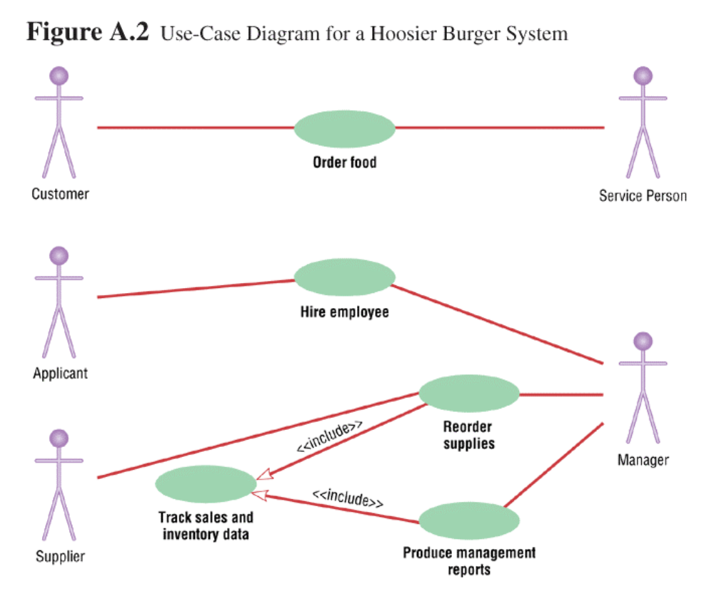
One kind of relationship is include, labeled with the extend <<include>> symbol
-It is a relationship between two use cases where one use case uses the functionality contained in the other
-It implies that one case uses another use case while executing. e.g
i) When a manager reorder supplies, the sales and inventory data are tracked.
ii) When a manager produce management reports the sales and inventory data are tracked.
-Such a use case (Track sales and inventory data) that is never executed on it self is called an abstract use case
NB: There is no connection between the actor and the abstract use case

Example 2
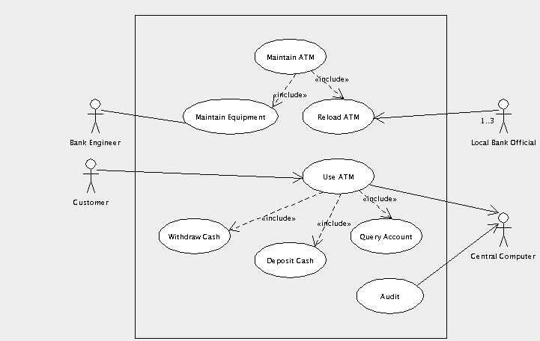

Another kind of relationship is extend labeled with the <<extend>> symbol.
-It is a relationship between two use cases where one use case adds new bahaviour or functionality to the other.
Example 1
-Consider the use case diagram below for university registration.

-The “Registration for special class” use case extends the “class registration” use case by capturing the additional actions that needs to be performed in registering a student for a special class. Registering for special class requires prior permission of the instructor, in addition to other steps carried out for regular registration.

-Extend relationship also occurs between identication of “ prerequisite course not completed ” use case and “class registration ” use case. The former extends the later in situations where the student registering for a class has not taken prerequisite courses.
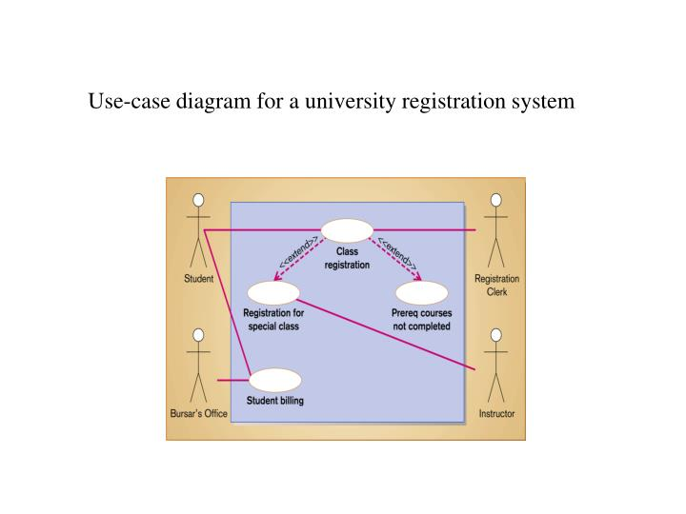
Extend is a directed relationship that specifies how and when the behavior defined in usually supplementary (optional) extending use case can be inserted into the behavior defined in the extended use case.
Extended use case is meaningful on its own; it is independent of the extending use case. Extending use case typically defines optional behavior that is not necessarily meaningful by itself. The extend relationship is owned by the extending use case. The same extending use case can extend more than one use case, and extending use case may itself be extended.
The extension takes place at one or more extension points defined in the extended use case.
Extend relationship is shown as a dashed line with an open arrowhead directed from the extending use case to the extended (base) use case. The arrow is labeled with the keyword «extend».

Registration use case is complete and meaningful on its own.
It could be extended with optional Get Help On Registration use case.

Summary
Include is used to extract use case fragments that are duplicated in multiple use cases. The included use case cannot stand alone and the original use case is not complete without the included one. This should be used sparingly an only in cases where the duplication is significant and exists by design (rather than by coincidence).
For example, the flow of events that occurs at the beginning of every ATM use case (when the user puts in their ATM card, enters their PIN, and is shown the main menu) would be a good candidate for an include.
Extend is used when a use case conditionally adds steps to another first class use case.
For example, imagine "Withdraw Cash" is a use case of an ATM machine. "Assess Fee" would extend Withdraw Cash and describe the conditional "extension point" that is instantiated when the ATM user doesn't bank at the ATM's owning institution. Notice that the basic "Withdraw Cash" use case stands on its own, without the extension.

